**Summer Tours**

Mark your calendars!

The Huerfano County Historical Society’s summer tours are just around the corner!

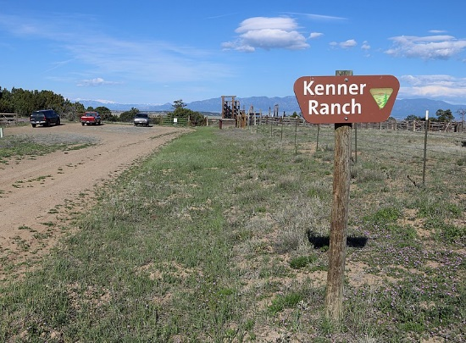***Historic Kenner Ranch on the Cucharas Canyon Tour***

**Saturday, May 18 at 9a**

Pack a sack lunch and a folding chair then meet us at the Walsenburg Mining Museum at 9a. Allow approximately 4 hours. We encourage car-pooling to the site which is located 16 miles northeast of Walsenburg. Beware the terrain is rather rough. Some may wish to explore further in the canyon while others remain topside.

Historian John Van Keuren will be our guide and guest speakers are Bob and Karen Tripp.

The BLM acquired this parcel in 1998 due to its unique natural archeological values and cultural resources. The area has been recognized as an area of cultural heritage of Native Americans, settlers, and ranchers. All of which will be discussed on the tour.

$10 per member/$15 for non-member.

Children under 12 are free. Payment due the morning of.

A reservation isn’t required, but let us know you’re coming!

Call The Heritage Center at 719-738-2346

or email HuerfanoHeritageCenter@outlook.com.

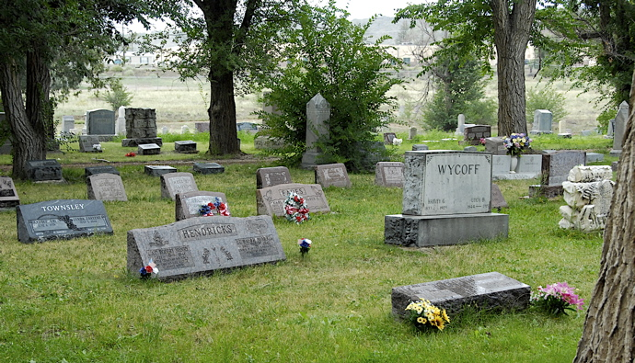

***Huerfano Masonic Cemetery Tour***

On West Elm Street, Walsenburg (behind the Spanish Peaks Library)

**Sunday, June 2 at 2p.** (Rain date will be Sunday, June 16 at 2p)

Reenactors will be placed at various gravesites as Historian Carolyn Newman leads us on a journey through the cemetery sharing stories of the past and honoring the rich history of Huerfano County.

The event will be FREE to Huerfano County Historical Society members.

$5 for non-members. Children under 12 are free.

Payment due the morning of.

A reservation isn’t required, but let us know you’re coming!

Call The Heritage Center at 719-738-2346

Or email [HerfanoHeritageCenter@outlook.com](mailto:HerfanoHeritageCenter@outlook.com).

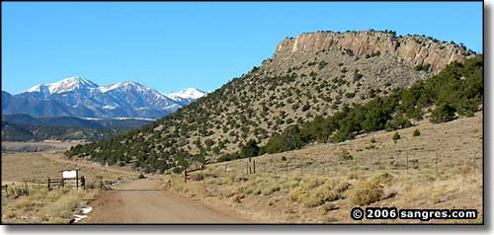***Upper Huerfano Valley Tour***

**Saturday, August 3**

**Details coming soon.**

This tour is being arranged in conjunction with the annual Gardner Chuckwagon Dinner.